A Literature Survey on IoT Based Safety Gadget for Child Safety Monitoring and Notification

# PAPER 1: SMART CHILD SAFETY WEARABLE

**DEVICE:**

**Year: Proceedings of the International Conference on Electronics and Sustainable Communication Systems (ICESC 2020) IEEE Xplore**

The device is made to switch on by the child to track or store the child data. The data is stored in a cloud over a WIFI network which can be seen for many days.When the child is lost or kidnapped he/she can press the SOS key on the device the gives the alert to the parents.

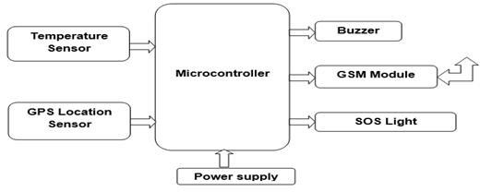

***Existing Working Model***

# PAPER 2-ANOMALY DETECTION IN WEARABLE LOCATION TRACKERS FOR CHILD SAFETY

**Year : Received 11 February 2021; Received in revised form 2 February 2022; Accepted 25 April 2022 .0141-9331/© 2022 Elsevier B.V. All rights reserved**

In this paper, a machine learning-based tracker was developed for detecting anomalous behavior in child movements from prior historic data of their normal routines.

Therefore, the main contributions of this paper are as follows:

1. The design and fabrication of a robust low-power electronic tracker for child safety.
2. Determination of the best unsupervised algorithm for spatial

temporal outlier detection in child trackers.

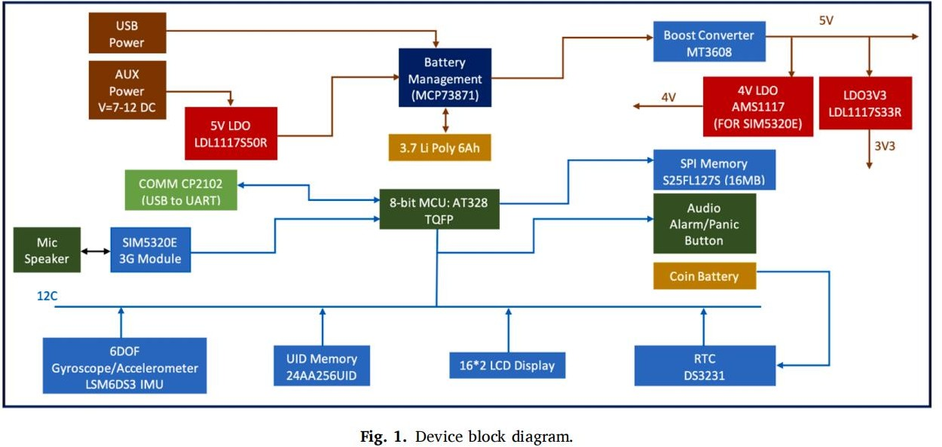

# PAPER 3-AN ANDROID APPLICATION OF SCHOOL BUS TRACKER BASED ON RFID TECHNOLOGY

**Year: 2020 International Conference on Computer, Control, Electrical, and Electronics Engineering (ICCCEEE)**

Global Positioning (GPS) technology to provide real time coordinates of the school bus. Tracking system is the needed solution to avoid forgotten them inside school buses or kidnapped them. The proposed system is an interactive android application for tracking developed mainly to be used in sudan. The system is based on RFID passive technology with real-time GPS tracking and a database located in a server.

# PAPER 4-IOT BASED INTELLIGENT REAL-TIME SYSTEM FOR BUS TRACKING AND MONITORING

**Year: 2020 International Conference on Power Electronics & IoT Applications in Renewable Energy and its Control (PARC) GLA University, Mathura, UP, India**

RFID card is used for identification of children. When a student enters into a bus, the RFID tag is detected by the reader in the bus and by authenticating the student details; it will send the message of real coordinates of location to the parent’s mobile phones.

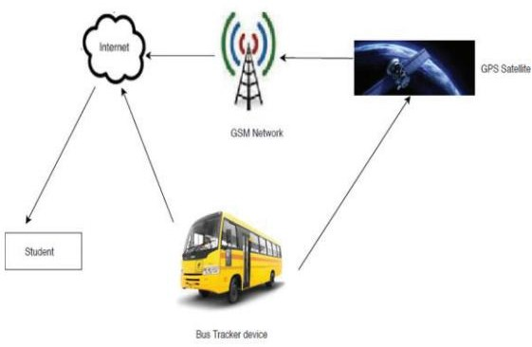

# PAPER 5-GEOFENCE ALERTS APPLICATION WITH GPS TRACKING FOR CHILDREN MONITORING (CTS)

**Year :** [**2021 International Conference on Software**](https://ieeexplore.ieee.org/xpl/conhome/9536945/proceeding) **Engineering & Computer Systems and 4th International Conference on Computational Science and Information Management (ICSECS-ICOCSIM)**

In this paper, the Geofence Alerts Application with GPS Tracking for Children Monitoring (CTS) is proposed with aim to provide parents with the real-time location of the children using their smartphone. Additionally, the application enables parents to set a geofence area of a determined safe place and get a notification when the children enter or leave the area. The application will also notify the parents when their children did not enter the geofence area at the time which set earlier. As information on where the children were abducted or where they had been in the past is important to the authorities, the application is capable to provide the parents with the history route passed by the children within the timeframe set by the parents. All the information displayed on the application is acquired in real-time using GPS technology